# YSR APPROVAL WORKFLOW BUILDER

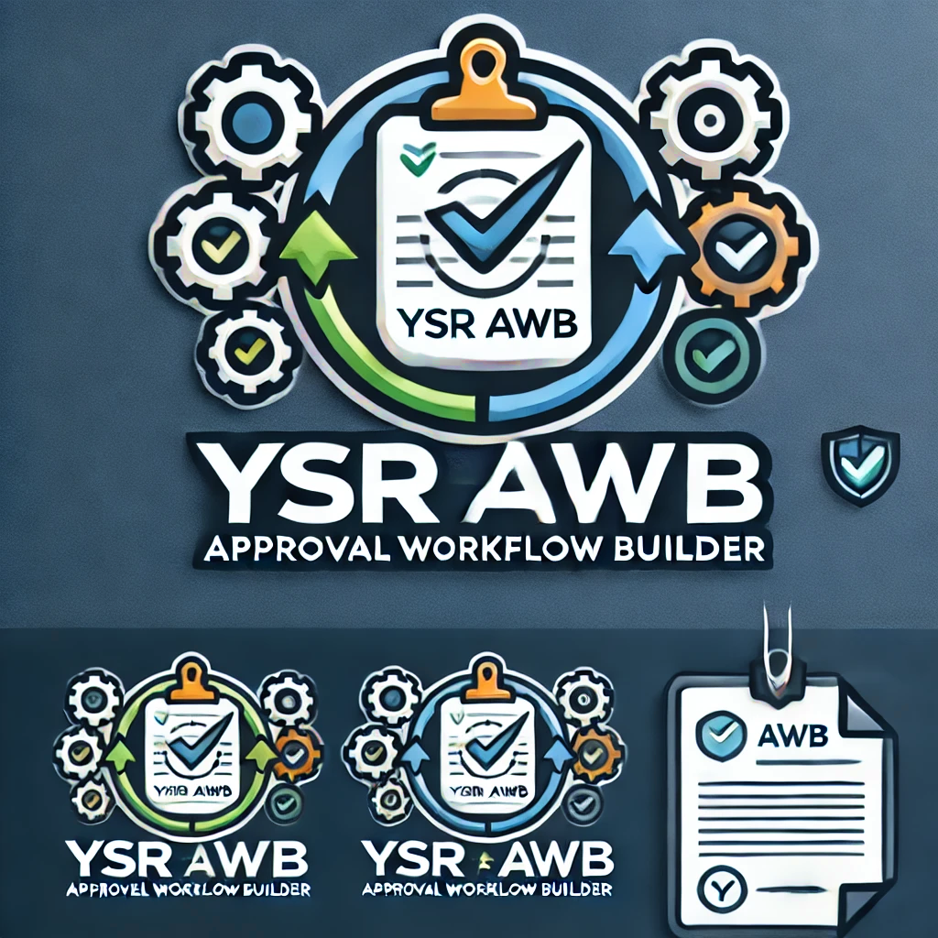

Table of Contents

Product Overview 1

The Challenge We Solve 1

Key Benefits 1

Getting Started 2

System Requirements 2

Installation 2

Permission Setup 2

Accessing the Application 2

Setting Up Approval Workflows 2

Workflow Setup List 2

Creating a New Workflow Configuration 2

Workflow Setup Card - General Settings 2

Workflow Settings 3

Setting Up Related Pages 3

Creating the Workflow 3

Managing Workflows 3

Creating Workflows for Multiple Tables 3

Deleting Workflows 3

Generating Extension Packages 3

Using Workflows 4

Approving or Rejecting Requests 4

Advanced Features 4

Adapting to Business Changes 4

Multi-Company Support 4

Troubleshooting 4

Common Issues 4

Getting Support 5

Appendix 5

Integration 5

**Introduction**

### Product Overview

YSR Approval Workflow Builder is a comprehensive solution for Microsoft Dynamics 365 Business Central that revolutionizes how organizations implement and manage approval processes. This powerful product enables users to create, customize, and deploy sophisticated approval workflows for any table in Business Central—all without requiring developer intervention or custom coding.

### The Challenge We Solve

Traditional workflow implementation in Business Central often requires specialized development resources, extensive customization, and significant time investment. Many organizations struggle with:

* Limited flexibility in standard approval processes
* High development costs for custom approval workflows
* Long implementation timelines
* Maintaining consistency across different approval scenarios

YSR Approval Workflow Builder eliminates these challenges by providing a user-friendly, configuration-based approach to workflow creation.

### Key Benefits

* **Cost Reduction**: Eliminate development costs for custom approval workflows
* **Time Savings**: Implement approval workflows in minutes instead of days or weeks
* **Business Agility**: Easily modify workflows as business needs change
* **Consistency**: Apply the same approval logic across multiple business scenarios
* **User Empowerment**: Business users can configure workflows without IT involvement
* **Governance**: Maintain proper controls and approvals across your entire system

### Getting Started

### System Requirements

* Microsoft Dynamics 365 Business Central SaaS
* User must have appropriate permissions (SUPER or YSR AWB Permission Set)

### Installation

The YSR Approval Workflow Builder can be installed from Microsoft AppSource or contact our team to install it.

### Permission Setup

1. Search for **Permission Sets**
2. Find the **YSR AWB Permission** permission set
3. Assign this permission set to appropriate users

### Accessing the Application

1. Search for **Approval Workflow Builder Setup**
2. This opens the setup list page where you manage workflow configurations

## Setting Up Approval Workflows

### Workflow Setup List

Displays all configured approval workflows. From this page, you can:

* View, create, edit, enable/disable workflows
* Create/delete workflow templates

### Creating a New Workflow Configuration

1. Click **New** on Workflow Setup List
2. A new setup card opens

### Workflow Setup Card - General Settings

* **Table ID**: Select the target table
* **Table Name**: Auto-filled
* **Enabled**: Toggle workflow status
* **Status Field No.**: Select/create a status field
* **Create Status Field**: Set to Yes if creating a field via extension

### Workflow Settings

* **Primary Key Field No.**, **Workflow Status Field No.**, **Table Extension ID**

### Setting Up Related Pages

* Click **Manage Related Pages**
* Add pages with approval buttons

### Creating the Workflow

Click **Create Workflow** to generate necessary components

## Managing Workflows

### Creating Workflows for Multiple Tables

Click **Create All Workflows** from the list

### Deleting Workflows

* **Delete Selected Table Workflow**
* **Delete All Workflows**
* **Complete Workflow Cleanup**

### Generating Extension Packages

* Click **Generate Extension Package**
* System creates a downloadable code package in Zip
* Extract the Zip file and import folder into VS Code and hit F5 (to publish)
  + Yes, Publish directly to your Sandbox
  + Use the .app file by publishing for Production deployment

## Using Workflows

After publishing to your environment, you can see below action buttons to use for your process

* Send Approval Request
* Cancel Approval Request
* Reopen
  + Reopen can be used to block modification on your record specially - Masters

### Approving or Rejecting Requests

This is same as base functionality:

* Go to **Requests to Approve**
* Select and click **Approve**, **Reject** or **Delegate**

## 

## Advanced Features

### Adapting to Business Changes

* Update configuration
* Delete old workflow and recreate

### Multi-Company Support

Each company can have separate configurations

## Troubleshooting

### Common Issues

**Workflow Not Created**: Check Table ID and fields

**Send for Approval Not Available**: Ensure page is linked

**Status Not Updating**: Verify correct Status Field No.

**Delete Error**: Cancel pending requests before deleting

### Getting Support

* Review this documentation
* Contact your Business Central partner

## Appendix

### Integration

Uses standard Business Central approval logic